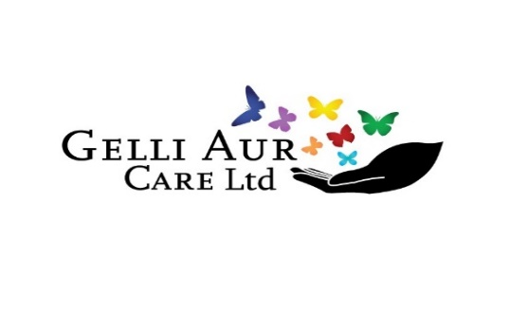
Resident Guide

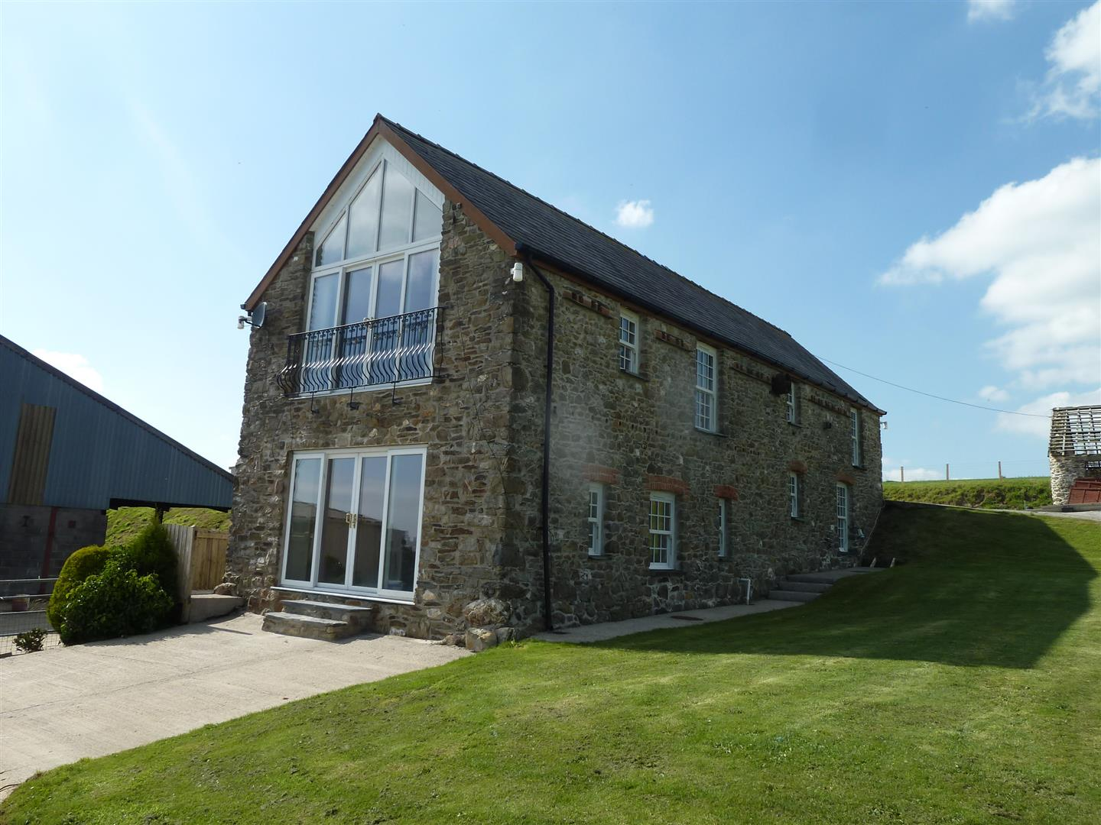

 |  | 

Gelli Aur Care Home
Meidrim
St Clears
SA33 5PS
Service Information

Registered Provider: Gelli Aur Care LTD

Directors: Hefyn & Pam

Responsible Individual: Helen

General Manager (Registered): Sian

Operational Manager: Tony

Deputy Operational Manager(s) Anwen
Ashley

Welsh Champion: Anwen

Safeguarding Officer: Sian

Address Gelli Aur Care Ltd
Cefn Cloch
Meidrim
Carmarthenshire
SA33 5PS

Telephone/Fax: 01994 484773

Email: Sian sian@gelliaurcare.onmicrosoft.com
Tony tony@gelliaurcare.onmicrosoft.com
Helen helen@gelliaurcare.onmicrosoft.com
Anwen/Ashley depopmanager@gelliaurcare.onmicrosoft.com

Speciality of the Home:
Gelli Aur Care is a residential home, committed to providing specialist care for individuals, with learning disabilities and co-existing mental health issues.

Staffing Structure

Registered Provider Gelli Aur Care Ltd

Service Provider: Hefyn
Responsible Individual: Helen
General Manager: Sian
Operational Manager: Tony

Deputy Operational Manager/Lead Co-ordinator: Anwen
Deputy Operational Manager/Lead Co-ordinator: Ashley
Operational Co-ordinator: Simon

Team Leader: Ross
Support Staff:- Isobel
Whitney
Kelly
Nick
Barry
Sheena
Tesni
Andrew
Pam
Christopher
Jordan
Corrie
Faye
Kay
Dai Phillips

Philosophy of Care

People with learning disabilities are entitled to lives which are as full as anyone else’s. Although we are all different, there are some core things we all have in common. We aim to provide the highest quality of person centred care to you. The central focus of our philosophy of care is to promote your well-being and fulfillment. We believe that you, your family, and friends should be informed partners in the provision of this care and beliefs and wishes are respected and valued.

Support staff will strive to preserve and maintain your dignity, individuality, and privacy within a warm and friendly atmosphere, and in doing so will be sensitive to your ever-changing needs. You will be encouraged to participate in the development of your individual personal plan, in which the involvement of family and friends may be appropriate and is highly valued.

It is important for most people and in line with any legal restrictions imposed on an individual to:
- Be part of a community
- Have good relationships with friends and family
- Have relationships that last
- Have opportunities to develop experience and learn new skills
- Have choices and control over life
- Be afforded status and respect and be treated as an individual
- Have a secure, stable, and comfortable environment whilst receiving a standard of individual psychological and physical care ensuring individuals are happy and content
- Have their dignity always maintained
- Receive stimulation and maintain physical and psychological activities, setting realistic targets and receiving encouragement to participate in decision making in attempt to reach these targets
- Enhance the quality of life by having a safe, secure, comfortable, and supportive environment to live in
- Have the right to personal choice especially in relation to clothes, diet, and activities
- Receive the encouragement to care for themselves where they are willing and able, and to regularly update personal plans to reflect this
- Be treated as an individual and receive the respect for his or her dignity
- Have the right to privacy by ensuring all staff knock before entering a room
- Have the right to be consulted in any proposed changes to their daily living arrangements and to receive encouragement to participate in making suggestions and decision making
- Have the right to choose their GP, Dentist, Optician, Podiatrist where possible. Full support is available to all residents to access and attend such visits and/or appointments
- Have the right to socialise within the community and be encouraged to invite family, friends, and acquaintances into their home
- Have the right to have their political, religious, and emotional needs accepted and respected

So important are these core elements of life that they have come to define what we mean by leading a socially valued lifestyle. Engagement in a full range of typical activities is part and parcel of such a lifestyle. Basic requirements for a full life are the opportunities to:
- participate in the full range of activities that everyone else does
- be involved and share interests with other people
- develop relationships, skills, and experience.

Core Values of Care

PRIVACY

DIGNITY

RIGHTS

INDEPENDENCE

CHOICE

FULFILMENT

COMMUNITY PRESENCE

Statement of Purpose
Gelli Aur Care is a purposely modified residential home, committed to providing specialist care for six individuals, with learning disabilities and co-existing mental health issues.

The home is situated within its own private grounds with spacious accommodation providing a well furnished sitting room, dining area, quiet room, a separate TV/movie/gaming area, gym area, an activity room with kitchen/cooking facilities and an external summerhouse with hot tub all of which have a welcoming and relaxed atmosphere. All areas within the home are furnished to a high standard and provide excellent facilities for residents including wifi access, games consoles, google speakers and smart TV’s.

Gelli Aur Care Ltd is owned by Hefyn and Pam Davies. A family owned business committed to supporting individuals with mental health issues and learning disabilities to live and fulfil their potential to the utmost.

Gelli Aur Care does not discriminate against those with a history of offending behaviours. Our bespoke service can provide residential care for individuals who have challenged existing care provisions and have difficulty in finding suitable long or short term placements.

Location of the Service
Gelli Aur Care is located near Meidrim in Carmarthenshire. A rural village situated approximately seven miles from the town of St Clears, nine miles from the town of Carmarthen and twenty miles from the Pembrokeshire border. Ideally situated to explore numerous towns and villages. The property is situated in 25 acres of private farmland, with countryside views and pleasant surroundings. Many picturesque and idyllic walks can be taken on the land and surrounding areas, including a natural woodland for individuals providing places to explore and connect with nature and a sense of well-being.

About the Service Provided
Gelli Aur Care provides 24-hour residential and/or supported living support for individuals with learning disabilities, mental health issues, autistic spectrum disorders and behaviours that may challenge the care provision. We do not discriminate against those who have offending or forensic backgrounds. We provide person centred holistic support in a safe, secure, and uplifting environment for long- or short-term placements.
Accommodation
The accommodation is a converted barn, an independent lodge and a separate 2-bedroomed lodge situated in private grounds. All works have been carried out to the highest standard with fantastic views over the countryside. Gelli Aur Care benefits from over 25 acres of private land. There are numerous trails and walks surrounding the setting which can be enjoyed. The home is situated just 5 minutes from St Clears, near the village of Meidrim. Carmarthen is 8 miles away, and the Pembrokeshire border is only 5 miles away. Some of the UK’S best beaches are within a 30-minute drive.

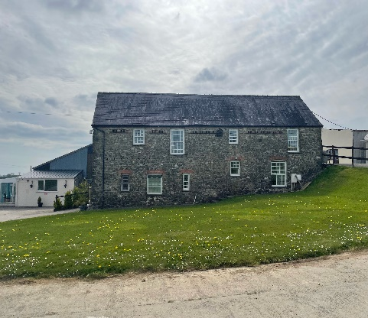 | 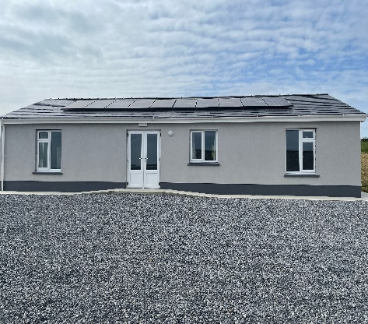 | 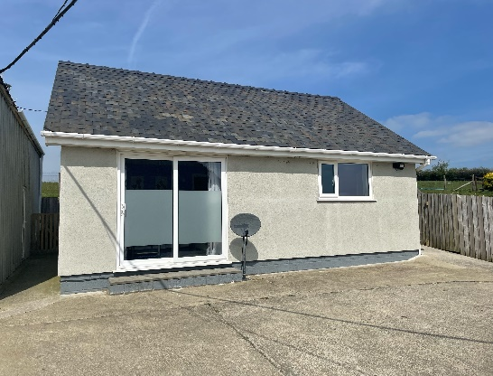

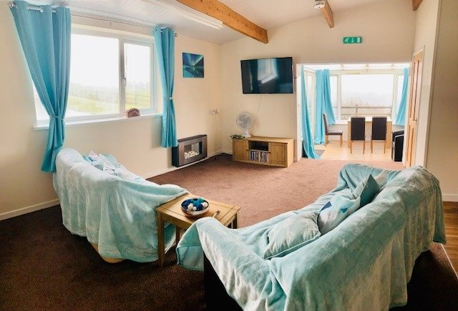 | 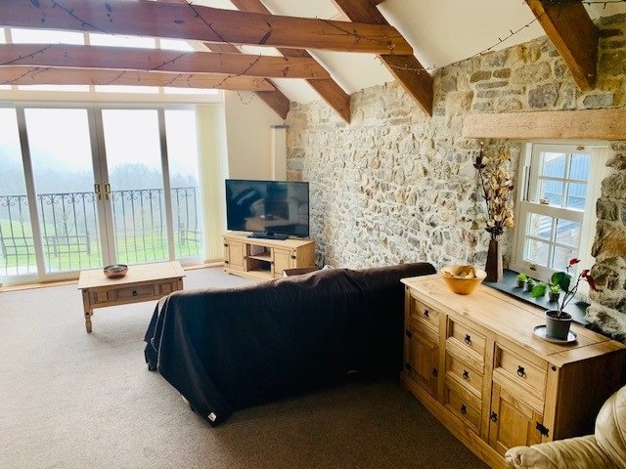

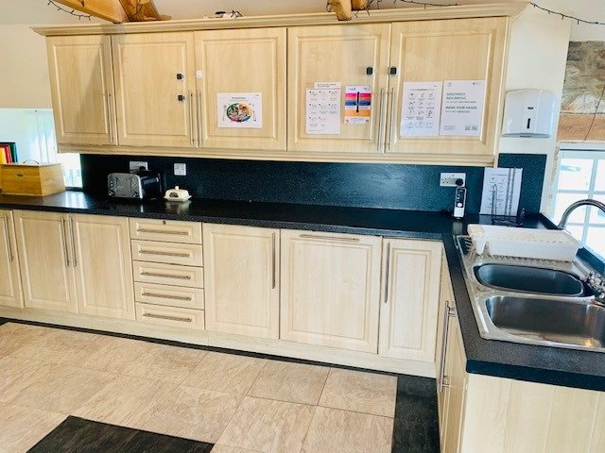 | 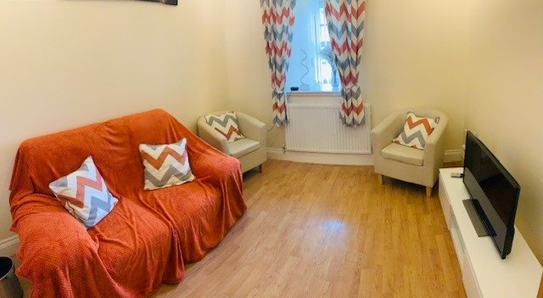 | 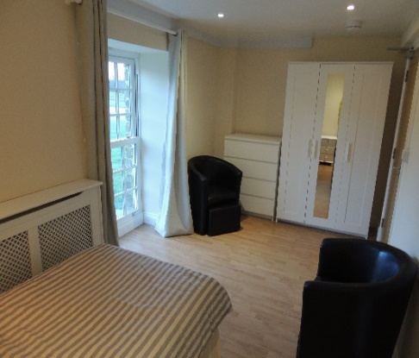

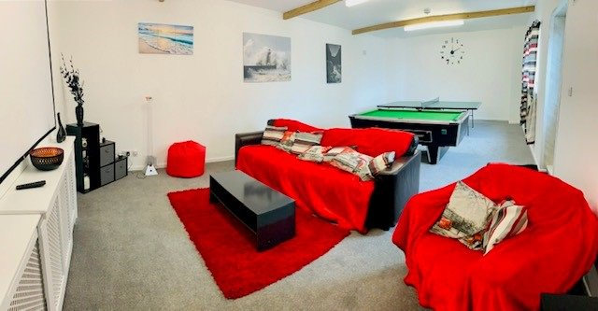 | 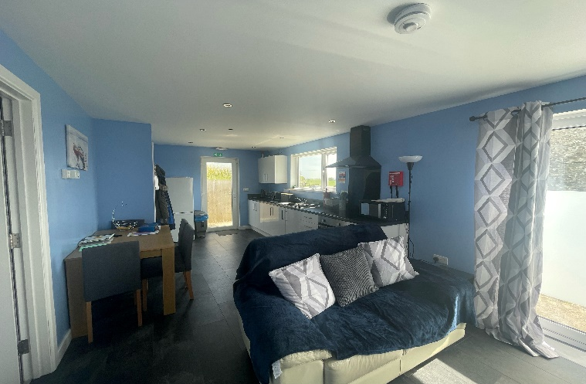

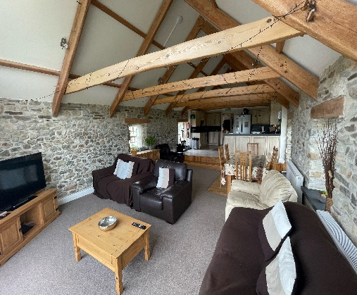 | 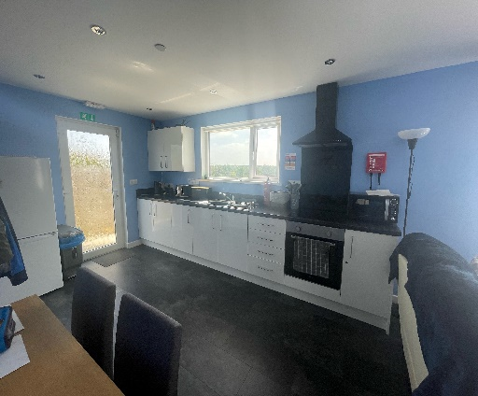 | 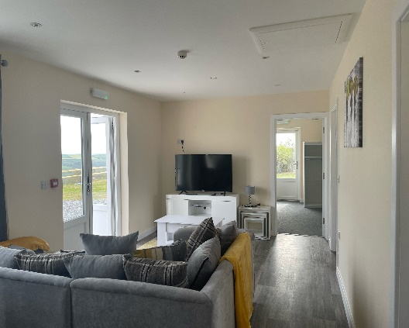

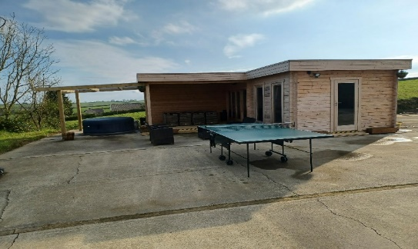 | 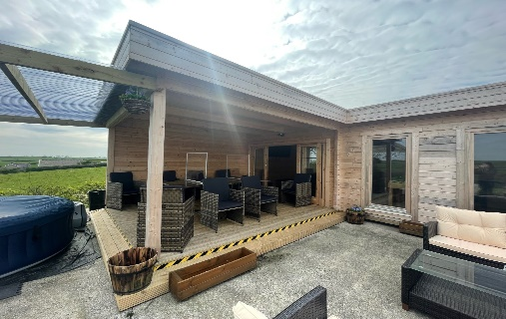

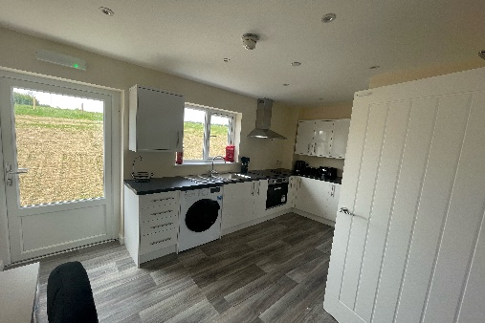 | 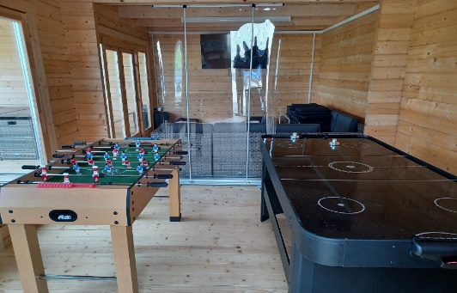 | 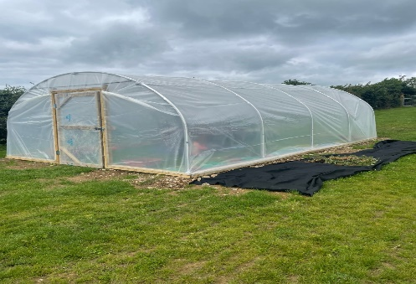

Aims & Objectives
Aims
Gelli Aur Care is committed to supporting service users to lead a fulfilled life, in an environment which:
- Provides a safe, supporting and homely environment
- Provides an environment where service users are supported in realising their full potential
- Ensure that individual beliefs, lifestyle choices and cultural differences are respected
- Promote maximised independence and integration into the community

Objectives
The company’s aims are achieved through care provision based on the following objectives:
- Individuals are involved in all aspects of daily living, activities, and lifestyle choices.
- All individuals have a personal keyworker with whom they can develop a professional relationship in order to access resources, advocacy and express any and all feelings.
- A care planning system which will be based upon ongoing individual assessment of strengths, capability, and needs.
- Full support will be provided to all individuals in order for them to establish and maintain relationships external to the home.
- An environment which values diversity amongst individuals e.g. individuals with different racial, cultural, spiritual backgrounds and of varying age, sexual orientation, and gender.

Mission Statement

“Gelli Aur Care aspire to the highest levels of expert care, enhancing the quality of life
and wellbeing of individuals residing at our home.
Our focus is on a person centered, holistic approach, encouraging and assisting individuals
to pursue dreams, and goals, to maximize their potential, giving them fulfilment.”

Activities

A planned structured week of activities is set, and individuals can choose what they would like to participate in. During the week support staff will discuss with you, activities on offer and complete Individual activity planners with you. A range of activities are offered including:

Cycling, Jogging, Basketball, Golf, football, Cricket, Darts, Pool, Gardening, Art, Cooking, Photography, Guitar lessons, Games

Community activities available around the area are, Cinema, Bowling, Theatre, Swimming, Gym Aerobics, Restaurants & Pubs, and places of worship.

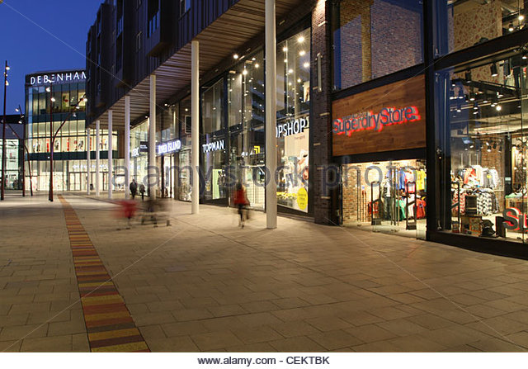 | Carmarthen Town  

 | 
Bowling |  | Cinema in Carmarthen Town

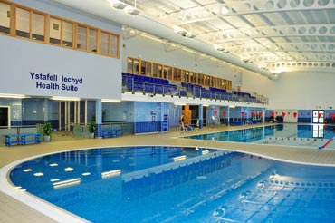 | 
Carmarthen Leisure Centre |  | Carmarthen Golf

Walks around Carmarthen

 | 

 | 

 | 

 | 

Staffing

All Staff are appropriately qualified to deliver the highest standards of care and support. A continuous staff training programme is implemented to ensure that these high standards are maintained in line with the latest developments in Care Practices as may be laid down in appropriate Legislation, Regulations and CIW.

The team at Gelli Aur Care will encourage and support you to pursue social activities both in and out of the home. This also includes education, training, and employment opportunities. The team encourage this by explaining the importance of social interaction within the Local and Wider Community and encourage individuals to participate in community activities. Residents at Gelli Aur Care are encouraged and supported to access places of interest and holidays both domestic and abroad. Discussions take place daily between staff and individuals relating to activities, these are recorded with a weekly activity suggestion plan and used to produce a weekly activity planner. Staff work in an innovative manner, looking at ways to improve the skill set of individuals.

There is a rigorous recruitment process for people who apply to work at Gelli Aur Care. All staff are provided with a robust two week induction programme focussed on the All Wales Induction Framework, with additional internal training supplemented by external courses to ensure we provide a skilled work force to meet the needs of the people living at Gelli Aur Care.

The company emphasises the importance of residents need for respect, dignity, privacy and autonomy. All staff are currently undertaking or have completed their NVQ or QCF qualification awards. An experienced care consultant provides support to the Responsible Individual and the Manager on a regular basis. Staffing levels are reviewed on a regular basis in line with the assessed needs of the residents. As part of the induction plan, staff will undertake the following by a qualified trainer:

  - Care code of conduct
  - Confidentiality
  - The rights of individuals
  - Health and Safety
  - Person-Centred Care
  - Respect, Dignity and the Wellbeing Act
  - Roles and responsibilities
Admission

Potential residents are encouraged and invited to visit the home prior to a placement. Transitional periods are actively encouraged, emergency placements and arrangements can be facilitated if required on an individual basis.

Fire Safety

All premises within the setting are fitted with modern fire alarm systems, a sprinkler system, fire extinguishers and emergency lighting as advised by the local Fire Authority. External speaker alarms are fitted to ensure these can be heard around the setting.

Staff are instructed during the induction training regarding the Fire Prevention/Drills Policy this includes use of the homes fire appliances, evacuation, muster points, raising the alarm, etc. Residents are informed of the emergency procedure during admission.

A full fire drill is conducted twice monthly which involves evacuation of the home.

All fire systems and alarms are tested weekly by staff of the home and annually by the local Fire Officer. Records are kept of all such testing as part of the Service Provider/Management responsibilities.

A qualified fire extinguisher maintenance engineer checks all firefighting equipment annually.

All furniture, fixtures and fittings will be made of fire-resistant or fire-retardant fabrics and materials.

Your Key Worker or dedicated staff will go through the fire procedure when you move in and ask you if you have understood the emergency procedure in the event of a fire.


Religion

All individual religious beliefs will be respected. Management and care staff will support all residents wishing to attend religious services outside of the home where necessary to meet your needs.

Residents have the right to meet clergy of their chosen denomination at any time. If required, a private room will be made available for such meetings.



Contact with Family and Friends.

Full support will be provided for you to maintain existing relationships and establish new ones.

You will be supported to receive guests, where appropriate, either in your own room, the home’s communal areas or quiet space. Staff support and supervision will be available at all times/as required.

All mail is the property of the individual, unless stated in specific risk assessment and support plan.

Residents are also encouraged to invite family or friends to their care review meetings.

Medication

If a resident wishes to self-medicate and itis safe to do so as agreed by the care team, and health professionals then support, and advice will be provided. Otherwise, all medication will be managed by trained competent staff, dispensed, and ordered on behalf of residents under the instructions of the Doctor.



Telephone

The home has a landline telephone, which can be used by you for incoming calls in the privacy of your own rooms. It can also be used for outgoing calls. The setting benefits from WiFi and smart TV’s however these are password protected with only specific staff having access. Residents can utilise the internet via their own or owned devices however monitoring may take place. Residents, if they choose can utilise their own routers and devices.



Meals

Meal planners are prepared weekly, and fresh nutritious meals daily, by residents supported by staff. Residents are encouraged to participate in the planning, shopping, and preparing of meals. The care we provide is aimed at promoting independence. Therefore, where possible all residents are encouraged to participate if they so wish.



Privacy and Dignity

Staff are trained and strive to preserve and maintain the dignity, individuality, and privacy of all residents within a warm and caring atmosphere, and in so doing will be sensitive to the residents ever changing needs.

Smoking

Gelli Aur Care offer a designated smoking sheltered area adjacent to the home. Smoking is not permitted within the interna areas of the setting

Personal Preferences

Gelli Aur Care encourage residents to contribute to the internal furnishings and décor of the setting, in particular personal preferences are requested for personal areas and ideas towards the communal areas. Residents are actively encouraged to take part in the up keep of areas and a feeling of their own space is promoted.



Pets

Gelli Aur Care is able to accommodate pets on discussion and agreement with the management team. Pets requiring indoor areas must be discussed and agreed with all residents.



Support Plan Review

The Support Plan comprises of the Personal Plan, Management Plan and any other plans, risk assessments required. These are regularly reviewed to ensure that they are appropriate in meeting the individual needs. Adverse reaction to the Support Plan by the Residents will result in an immediate review of the Support Plan by the named Lead Officer, Manager, Key Worker and other members of support staff as necessary.

Residents and their relatives are always encouraged to talk to a member of the Support Staff if they have any concerns.

The Support Plan is reviewed at three levels:
- Daily to ensure all staff are informed and aware of each resident’s needs.
- Monthly Audits/Workshops
- Three monthly evaluations to ensure that residents are on target to reach their desired outcome.

All amendments to the support plan will be in consultation and agreement with the individual, Management, relevant health professionals, and other agencies if applicable. All amendments to the Support Plan are recorded in full.

The views of the residents are very important to us, all residents are encouraged to participate in monthly house meetings where they can contribute towards the running of the service. Views can be shared by discussing with support staff.

Gelli Aur care is regulated by CIW and after each visit an Inspection Report is made available. Copies of these can be found on the CIW website, our website and by asking a member of the team who will provide this to you.

Complaints
Gelli Aur Care is committed to dealing with any concerns well and to providing a quality service so that everyone has a positive experience.

It is essential that individuals have absolute confidence in the services provided by us. We will ensure that if you have a complaint or concern, we will deal with it as quickly as possible and fairly, if you have a complaint or concern, please following the steps below:

- Speak to a member of staff who are on shift about your issue. Staff will check they understand the issue and will try to put things right.
- If you would like to make a complaint in writing, you can use the pre-printed complaints form.
- If you would like to discuss your complaint with a particular member of staff please advise the staff on shift, they can tell you when the relevant staff is on shift.
- If staff cannot put things right or you are still not happy this will be passed to the Senior Staff on shift. The senior on shift will talk to you about your concern and try and put things right.
- If you would like this concern or complaint to be dealt with by a Manager, staff can support you by writing down what you say or putting your concern onto Nourish. This will be read by a Manager and they will confirm they have had the concern within 5 working days.
- We will give you updates on your complaint and what has been done to make things right.
- The complaint will be looked at, this may mean we need to speak with you or other people. You can bring someone with you to these discussions to make you feel more comfortable if you would like. This should be completed within 20 clear working days.
- The results of the investigation will be discussed with you, if you are still not happy you can discuss this with Sian or Helen.
- If you would like to discuss your concern with an advocate let staff know and they can support, you to contact IMCA Wales.
You can also make a complaint to CIW (Care Inspectorate Wales), Social Services or the Public Services Ombudsman for Wales, staff can support you to contact them.

We take all concerns and complaints seriously and will make every attempt to learn from any mistakes made. Let us know what you are concerned about, and we will do everything we can to help you.

The use of an Advocate to support the resident if necessary is encouraged and details of how to contact are displayed within the home.
House Guidelines

- Treat everyone with respect
- No smoking in the internal areas of the setting, individuals should use the dedicated smoking area
- Meals should not be eaten in personal areas
- Quiet time is between 11pm and 7am daily
- The Communal Area should not be accessed between the hours of 11pm and 7am
- TVs within own bedroom, if on between the hours of 11pm and 7am must be low enough not to be heard outside bedroom
- Chores, both personal and communal should be completed
- You should always speak to staff if you need to leave the house between the hours of 11pm and 7am
- Unauthorised items should not be kept in personal areas i.e. dangerous items, unauthorised medication etc
- You should speak to staff if you are expecting visitors
- Bullying will not be tolerated
- Aggressive behaviour will not be tolerated
- Green paper towels must not be flushed down the toilets
- Please be appropriately dressed whilst in the communal area
- Be considerate to others at all times
- Ensure both personal and communal areas remain tidy, and things are put away
- Always maintain personal hygiene
- COSHH/sharps Cupboards to remain locked
- Wet clothes must not be hung around the house, these should be dried using the outside line, tumble drier or clothes horse within the laundry area

Financial Fees and Agreements

We are committed to providing high quality care and support for all residents within Gelli Aur Care.

The fees charged are dependent on:
1. The type of care package and needs of the individual.

Depending on the personal financial situation, a resident can either pay these fees privately or receive benefits arranged by Social Services. The current rules can be complicated, and specific advice is available from the Management Team

FEES – What is included
- Fully equipped accommodation inclusive of household expenditure
- Set budget for shopping, social and fuel
- Fully trained staff in 24-hour attendance
- Well balanced and nutritional meals
- Provision for special diets
- To liaise with all health professionals to promote maximum well-being.
- Management of regular visits to the Chiropodist, Dentist etc.
- Transportation around Carmarthenshire and neighbouring counties
- A high level of person-centred care in line with the individual needs
- Use of all facilities available within the setting

FEES – What is not included.
- Holidays and expenses
- Clothing and personal toiletries
- Personal choice of snacks & drinks (drinks, chocolates, sweets, fast food/takeaways etc.) as we promote healthy living.
- Podiatry, dental, optician, hairdressing costs
- Sky TV and personal use WiFi
- Fuel and costs for personal vehicles
- Legal fees and pet costs

